ecommerce_checkout | SBP
V1.0

Revision History
Version | Date | Description | Author
1.0 | 18/02/2026 | Initial Version | Mohammed Megahed

Reviewers
# | Name | Position | Date and Signature
1
2

Acceptance and Signoff
# | Name | Position | Date and Signature
1
2

Contents
1. Introduction 4
1.1. Project Summary 4
1.2. In-Scope 4
1.3. Out-Scope 4
1.4. Target Audience 4
1.5. Abbreviations 4
1.6. Assumptions, Dependencies and Risks 4
2. Requirements Compliancy Matrix 5
3. Solution Architecture 5
3.1. Solution Description 5
3.3. Non-Functional Requirements 6
3.4. Security Considerations 7
4. E-Commerce Checkout Flow 7
4.1. Sequence Diagram 7
4.2. Flow Description 8
4.3. APIs Contract Agreement 11
4.4. Error Handling 12
5. Order Fulfillment and Tracking 12
5.1. Sequence Diagram 13
5.2. Flow Description 13
5.3. APIs Contract Agreement 15
5.4. Error Handling 16
6. Appendix 23
6.1. Solution Architecture Reference Documents 23

1. Introduction

1.1. Project Summary
This project builds a shopping cart system that persists items across visits, validates real-time inventory, applies promotional codes, and handles multiple payment methods. Key capabilities include guest checkout, shipping calculation, and secure payment processing. The primary business benefit is improved customer experience and reduced operational costs.

1.2. In-Scope
# | Item
1. | Persistent shopping cart management
2. | Real-time inventory validation
3. | Promotional code and discount application
4. | Guest and registered checkout
5. | Multiple payment methods (Card, Apple Pay, COD)
6. | Order confirmation and receipt generation
7. | Real-time order tracking

1.3. Out-Scope
# | Item
1. | Product catalog management
2. | Customer reviews and ratings
3. | Loyalty program management
4. | Return and refund processing

1.4. Target Audience
# | Stakeholders
1. | Enterprise Architects
2. | Partners and Vendors Technical Leaders
3. | Infrastructure Architects & Engineers
4. | InfoSec Architects & Engineers
5. | Technical Managers
6. | Delivery Leads and Project Managers
7. | Developers

1.5. Abbreviations
# | Abbreviations | Full form
1

1.6. Assumptions, Dependencies and Risks
# | Item | Type | Owner | Comment
1.
2.

2. Requirements Compliancy Matrix
ID. | Title | Description | Compliancy | Comments
FR-BR-001 | Persistent Cart | This requirement enables persistent cart functionality for users. | Compliant
FR-BR-002 | Inventory Check | This requirement enables inventory check functionality for users. | Compliant
FR-BR-003 | Promo Codes | This requirement enables promo codes functionality for users. | Compliant
FR-BR-004 | Shipping Calculation | This requirement enables shipping calculation functionality for users. | Compliant
FR-BR-005 | Guest Checkout | This requirement enables guest checkout functionality for users. | Compliant
FR-BR-006 | Payment Processing | This requirement enables payment processing functionality for users. | Compliant
FR-BR-007 | Order Confirmation | This requirement enables order confirmation functionality for users. | Compliant
FR-BR-008 | Inventory Reserve | This requirement enables inventory reserve functionality for users. | Compliant
FR-BR-009 | Order Tracking | This requirement enables order tracking functionality for users. | Compliant
FR-BR-010 | Fulfillment Integration | This requirement enables fulfillment integration functionality for users. | Compliant

3. Solution Architecture

3.1. Solution Description
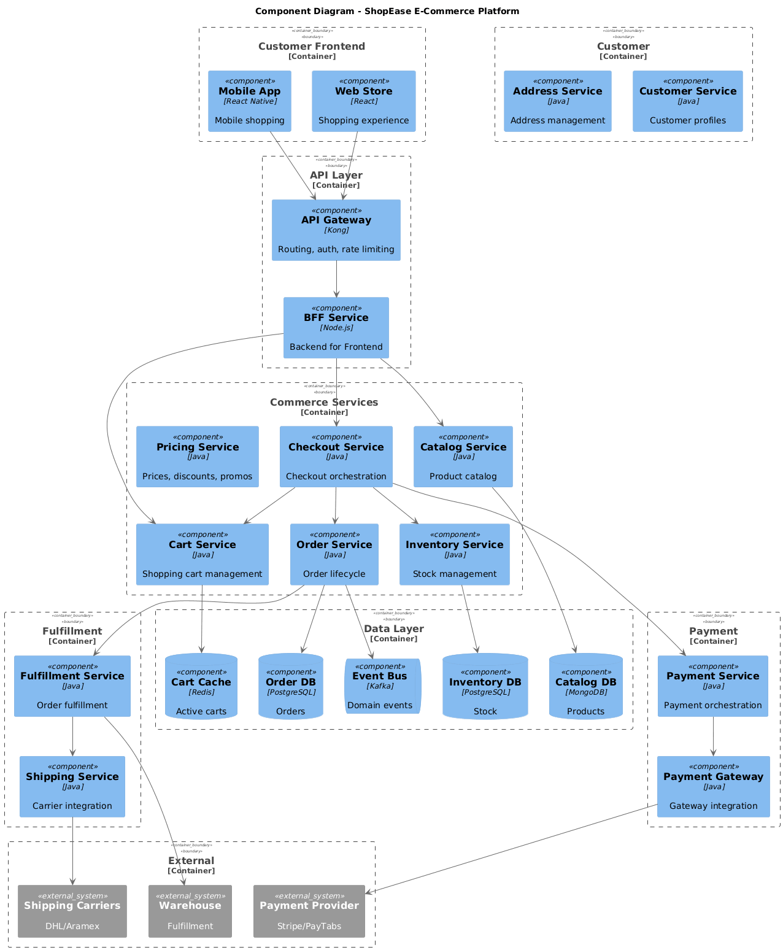

3.3. Non-Functional Requirements
# | Category | Requirement | Target/SLA
1 | Performance | API Response Time | < 2 seconds for 95th percentile
2 | Performance | Transaction Throughput | Support 100 TPS during peak hours
3 | Availability | System Uptime | 99.9% availability (excluding planned maintenance)
4 | Availability | Recovery Time Objective (RTO) | < 4 hours
5 | Availability | Recovery Point Objective (RPO) | < 1 hour
6 | Scalability | Horizontal Scaling | Support auto-scaling based on load
7 | Scalability | Concurrent Users | Support 1000 concurrent users
8 | Data Retention | Transaction Logs | Retain for 7 years as per regulatory requirements
9 | Data Retention | Audit Logs | Retain for 5 years
10 | Compliance | Regulatory | Comply with CMA and SAMA regulations
11 | Compliance | Data Protection | Comply with data privacy requirements

3.4. Security Considerations
# | Security Domain | Requirement | Implementation
1 | Authentication | User Authentication | OAuth 2.0 / JWT tokens with secure token storage
2 | Authentication | Service-to-Service Auth | Mutual TLS (mTLS) for internal service communication
3 | Authentication | Multi-Factor Authentication | MFA required for sensitive operations
4 | Authorization | Role-Based Access Control | RBAC implemented with principle of least privilege
5 | Authorization | API Authorization | Scope-based access control for API endpoints
6 | Data Protection | Data in Transit | TLS 1.2+ encryption for all network communication
7 | Data Protection | Data at Rest | AES-256 encryption for sensitive data storage
8 | Data Protection | PII/Sensitive Data | Data masking and tokenization for sensitive fields
9 | API Security | Input Validation | Server-side validation of all input parameters
10 | API Security | Rate Limiting | Rate limiting to prevent abuse and DDoS attacks
11 | API Security | CORS Policy | Strict CORS policy for web API endpoints
12 | Audit & Logging | Audit Trail | Log all security-relevant events with timestamps
13 | Audit & Logging | Log Protection | Immutable logs with tamper detection
14 | Vulnerability Management | Security Scanning | Regular SAST/DAST scanning in CI/CD pipeline
15 | Vulnerability Management | Dependency Scanning | Automated scanning for vulnerable dependencies

4. E-Commerce Checkout Flow

4.1. Sequence Diagram
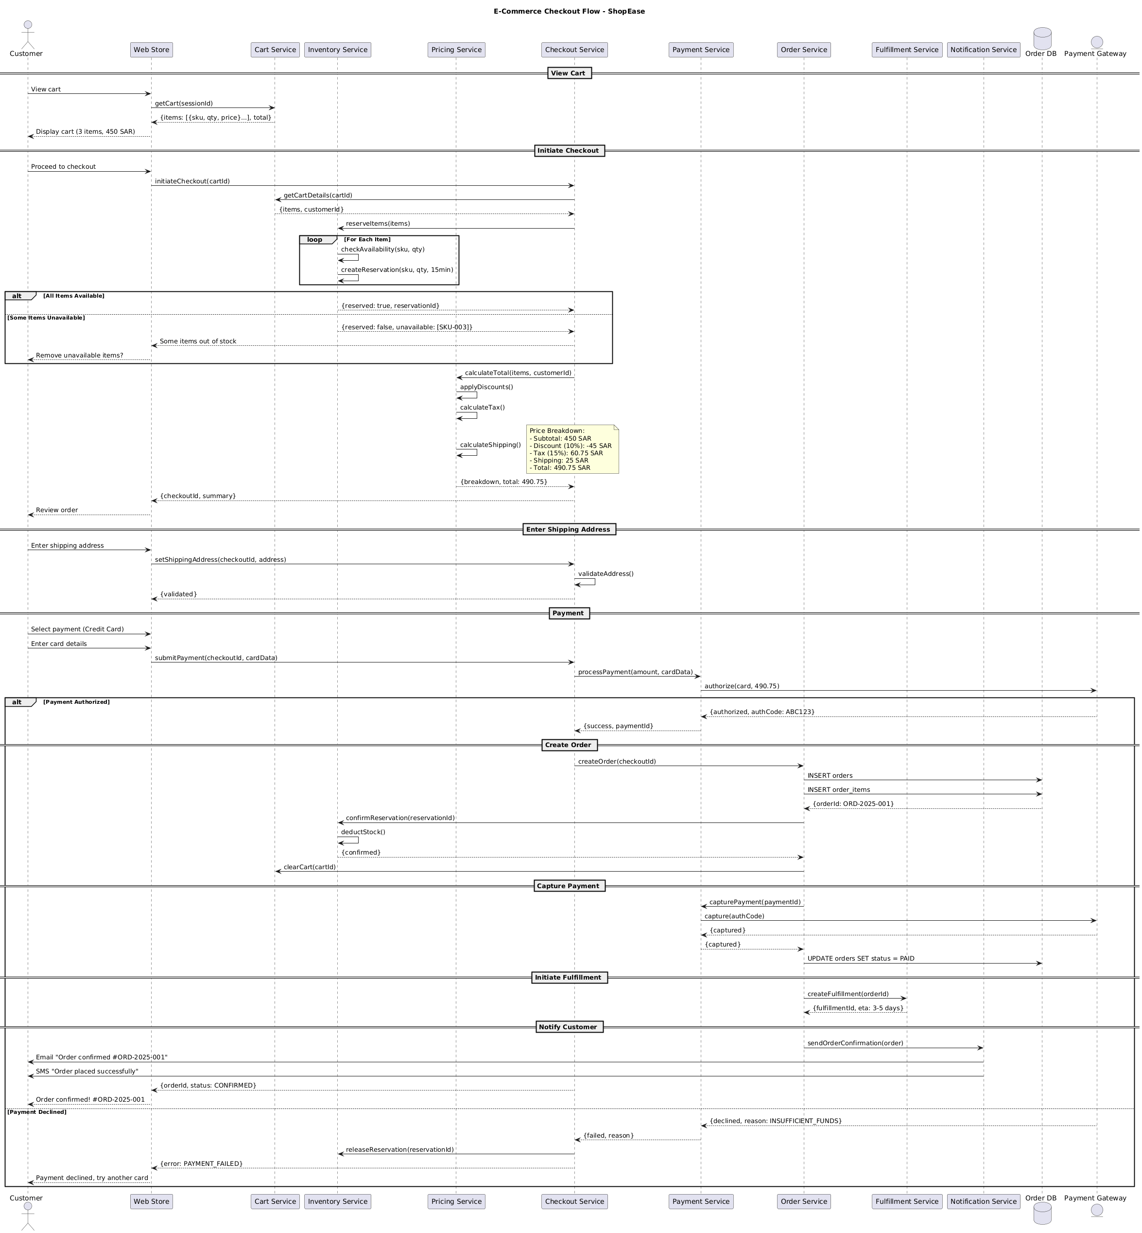

4.2. Flow Description
View Cart
• The customer views their cart on the web store.
• The web store retrieves the cart details using the cart service.
• The web store displays the cart, showing 3 items with a total of 450 SAR.
• Web Store internally performs: Display cart (3 items, 450 SAR).
Initiate Checkout
• The customer proceeds to checkout.
• The web store initiates the checkout process using the checkout service.
• The checkout service retrieves the cart details and reserves items.
• The checkout service internally checks the availability of each item.
• The checkout service internally creates a reservation for each item.
• If all items are available, the checkout service confirms the reservation.
• If some items are unavailable, the checkout service informs the customer and optionally allows them to remove unavailable items.
• The checkout service calculates the total amount, including discounts, taxes, and shipping.
• Checkout Service internally performs: Calculate total (items, customerId).
• Checkout Service internally performs: Apply discounts.
• Checkout Service internally performs: Calculate tax.
• Checkout Service internally performs: Calculate shipping.
• Checkout Service internally performs: Set the price breakdown.
• Checkout Service internally performs: Set the summary.
Enter Shipping Address
• The customer enters their shipping address.
• The web store sets the shipping address using the checkout service.
• The checkout service validates the address.
• Checkout Service internally performs: Validate address.
Payment
• The customer selects a payment method and enters card details.
• The web store submits the payment details to the checkout service.
• The checkout service processes the payment using the payment service.
• If the payment is authorized, the checkout service creates the order.
• If the payment is declined, the checkout service releases the reservation and informs the customer of the failure.
• Checkout Service internally performs: Capture payment.
• Checkout Service internally performs: Update order status.
• Checkout Service internally performs: Create fulfillment.
• Checkout Service internally performs: Send order confirmation.
Create Order
• The checkout service creates the order using the order service.
• The order service inserts the order and order items into the database.
• The order service confirms the reservation.
• The order service clears the cart.
• Order Service internally performs: Insert orders.
• Order Service internally performs: Insert order_items.
• Order Service internally performs: Update orders status.
Capture Payment
• The order service captures the payment using the payment service.
• The payment service captures the payment using the payment gateway.
• The payment service updates the order status.
• Payment Service internally performs: Capture payment.
• Payment Service internally performs: Update order status.
Initiate Fulfillment
• The order service initiates fulfillment using the fulfillment service.
• The fulfillment service creates the fulfillment using the fulfillment service.
• The fulfillment service updates the order status.
• Fulfillment Service internally performs: Create fulfillment.
Notify Customer
• The order service sends a confirmation to the customer using the notification service.
• The notification service sends an email and SMS to the customer.
• The web store updates the status of the order.
• Notification Service internally performs: Send order confirmation.
  - Authentication & Validation
Throughout the flow, authentication and validation are critical. The checkout service validates the customer's address and payment details. The payment service authorizes the payment and captures the transaction. The order service updates the order status and confirms the reservation. The fulfillment service creates the fulfillment and updates the order status. These validations ensure the integrity and security of the transaction.
  - Security
The flow includes several security measures. The payment service authorizes the payment and captures the transaction, ensuring the transaction is secure and the payment is processed correctly. The order service updates the order status and confirms the reservation, maintaining the integrity of the order. The fulfillment service creates the fulfillment and updates the order status, ensuring the order is fulfilled correctly.
  - Caching
Caching is used to improve performance. The checkout service caches the list of items and the summary, reducing the number of database queries. The order service caches the order items and the order status, further improving performance.
  - Error Handling
Error handling is robust. If the payment is declined, the checkout service releases the reservation and informs the customer of the failure. The order service updates the order status, and the fulfillment service updates the fulfillment status. These error-handling mechanisms ensure the flow can recover from failures and continue processing the order.
  - Parallel Execution
Parallel execution is used where appropriate. For example, the checkout service reserves items in parallel, and the

4.3. APIs Contract Agreement
# | Source | Destination | API | Protocol | Request Parameters | Response Parameters
1 | Web Store | Cart Service | getCart | REST | sessionId | {items: [{sku, qty, price}...], total}
2 | Web Store | Checkout Service | initiateCheckout | REST | cartId | Some items out of stock
3 | Checkout Service | Cart Service | getCartDetails | REST | cartId | {items, customerId}
4 | Checkout Service | Inventory Service | reserveItems | REST | items | {reserved: true, reservationId}
5 | Checkout Service | Pricing Service | calculateTotal | REST | items, customerId | {breakdown, total: 490.75}
6 | Web Store | Checkout Service | setShippingAddress | REST | checkoutId, address | {validated}
7 | Web Store | Checkout Service | submitPayment | REST | checkoutId, cardData | {orderId, status: CONFIRMED}
8 | Checkout Service | Payment Service | processPayment | REST | amount, cardData | {success, paymentId}
9 | Payment Service | Payment Gateway | authorize | REST | card, 490.75 | {authorized, authCode: ABC123}
10 | Checkout Service | Order Service | createOrder | REST | checkoutId
11 | Order Service | Order DB | INSERT orders | JDBC |  | {orderId: ORD-2025-001}
12 | Order Service | Order DB | INSERT order_items | JDBC
13 | Order Service | Inventory Service | confirmReservation | REST | reservationId | {confirmed}
14 | Order Service | Cart Service | clearCart | REST | cartId
15 | Order Service | Payment Service | capturePayment | REST | paymentId | {captured}
16 | Payment Service | Payment Gateway | capture | REST | authCode | {captured}
17 | Order Service | Order DB | UPDATE orders SET status = PAID | JDBC
18 | Order Service | Fulfillment Service | createFulfillment | REST | orderId | {fulfillmentId, eta: 3-5 days}
19 | Order Service | Notification Service | sendOrderConfirmation | REST | order
20 | Notification Service | Customer | Email "Order confirmed #ORD-2025-001" | REST
21 | Notification Service | Customer | SMS "Order placed successfully" | REST
22 | Checkout Service | Inventory Service | releaseReservation | REST | reservationId
[*] Indicates that the data element is optional

4.4. Error Handling
# | Source | Destination | Scenario | Handling
1 | Web Store | Inventory Service | checkAvailability  Unavailable SKU | Ensure idempotency to avoid duplicates on retry; Log error with correlation ID; Retry up to 3 times with exponential backoff; Notify user of failure
2 | Web Store | Pricing Service | calculateTotal  Duplicate Request | Ensure idempotency to avoid duplicates on retry; Log error with correlation ID; Queue request for asynchronous retry; Return cached response if available
3 | Web Store | Payment Service | processPayment  Payment Declined | Ensure idempotency to avoid duplicates on retry; Log error with correlation ID; Queue request for asynchronous retry; Return error code to upstream caller; Notify operations team via alert if repeated

5. Order Fulfillment and Tracking

5.1. Sequence Diagram
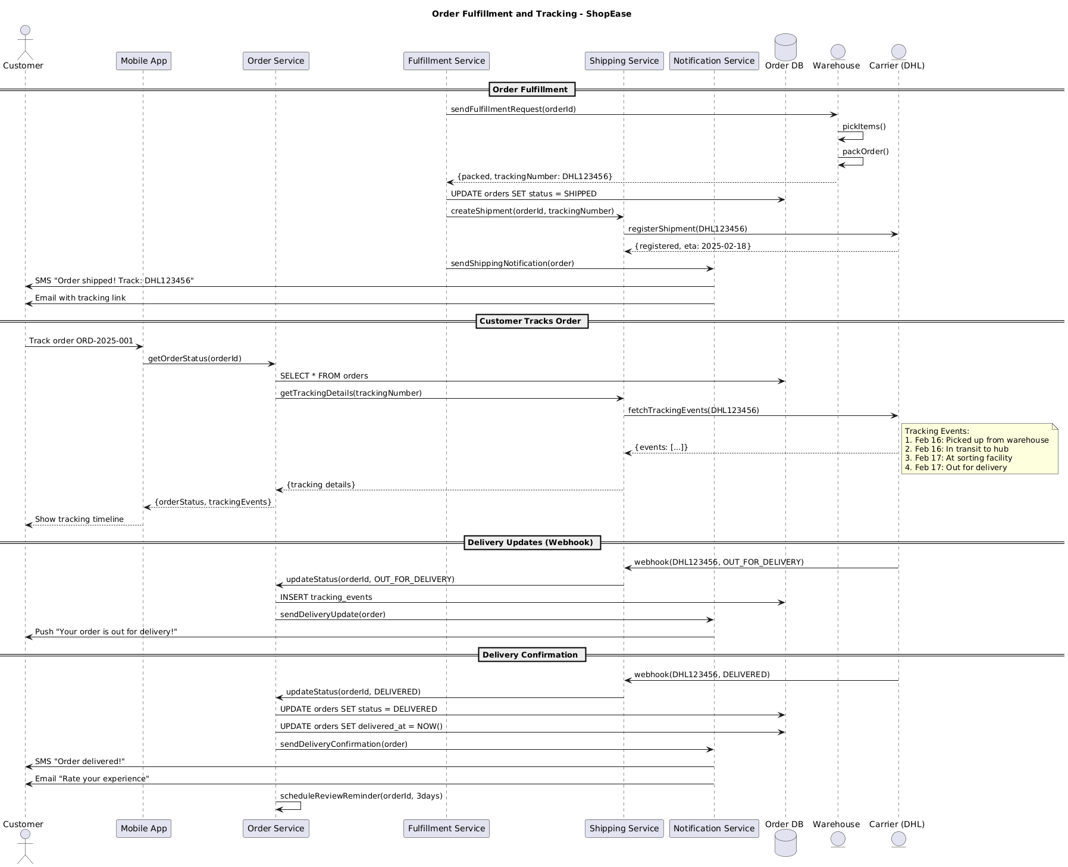

5.2. Flow Description
Order Fulfillment
The process begins with the Fulfillment Service initiating the order fulfillment by sending a request to the Warehouse to pick and pack the items. The Warehouse internally performs the operations of picking items and packing the order, and then sends a response indicating the packing status and the tracking number to the Fulfillment Service.
The Fulfillment Service updates the order status in the Order DB to SHIPPED and creates a shipment with a tracking number. The Shipping Service registers the shipment with the Carrier, and the Notification Service sends a shipping notification to the customer via SMS and email.
Control Structures and Conditions:
• The system repeats this interaction for each order fulfillment request.
• The flow terminates early when the shipment is registered and the tracking number is available.
Self-Interactions:
• Warehouse internally performs: pickItems()
• Warehouse internally performs: packOrder()
Customer Tracks Order
Once the order is shipped, the customer tracks the order through the Mobile App. The Mobile App retrieves the order status and tracking details from the Order Service and the Shipping Service. The Shipping Service fetches the tracking events from the Carrier and sends them back to the Mobile App.
Control Structures and Conditions:
• The system repeats this interaction for each tracking request.
• The flow terminates early when the tracking events are fetched and the tracking details are available.
Self-Interactions:
• Mobile App internally performs: getOrderStatus
• Mobile App internally performs: getTrackingDetails
Delivery Updates (Webhook)
The Carrier sends a webhook to the Shipping Service indicating that the order is out for delivery. The Shipping Service updates the order status and inserts tracking events into the Order DB. The Notification Service sends a delivery update notification to the customer via SMS and email.
Control Structures and Conditions:
• The system repeats this interaction for each delivery update.
• The flow terminates early when the delivery update is sent.
Self-Interactions:
• Carrier internally sends: webhook(DHL123456, OUT_FOR_DELIVERY)
• Carrier internally sends: webhook(DHL123456, DELIVERED)
Delivery Confirmation
The Carrier sends a webhook to the Shipping Service indicating that the order has been delivered. The Shipping Service updates the order status and inserts the delivered_at timestamp into the Order DB. The Notification Service sends a delivery confirmation notification to the customer via SMS and email.
Control Structures and Conditions:
• The system repeats this interaction for each delivery confirmation.
• The flow terminates early when the delivery confirmation is sent.
Self-Interactions:
• Carrier internally sends: webhook(DHL123456, DELIVERED)
• Carrier internally sends: webhook(DHL123456, DELIVERED)
Delivery Confirmation (Continued)
The Order Service schedules a review reminder for the customer 3 days after the delivery. This reminder is sent via the Notification Service.
Control Structures and Conditions:
• The system repeats this interaction for each delivery confirmation.
• The flow terminates early when the review reminder is scheduled.
Self-Interactions:
• Order Service internally performs: scheduleReviewReminder(orderId, 3days)
  - Notes
Tracking Events:
• Feb 16: Picked up from warehouse
• Feb 16: In transit to hub
• Feb 17: At sorting facility
• Feb 17: Out for delivery
  - End

5.3. APIs Contract Agreement
# | Source | Destination | API | Protocol | Request Parameters | Response Parameters
1 | Fulfillment Service | Warehouse | sendFulfillmentRequest | REST | orderId | {packed, trackingNumber: DHL123456}
2 | Fulfillment Service | Order DB | UPDATE orders SET status = SHIPPED | JDBC
3 | Fulfillment Service | Shipping Service | createShipment | REST | orderId, trackingNumber
4 | Shipping Service | Carrier (DHL) | registerShipment | REST | DHL123456 | {registered, eta: 2025-02-18}
5 | Fulfillment Service | Notification Service | sendShippingNotification | REST | order
6 | Notification Service | Customer | SMS "Order shipped! Track: DHL123456" | REST
7 | Notification Service | Customer | Email with tracking link | REST
8 | Order Service | Order DB | SELECT * FROM orders | JDBC
9 | Order Service | Shipping Service | getTrackingDetails | REST | trackingNumber | {tracking details}
10 | Shipping Service | Carrier (DHL) | fetchTrackingEvents | REST | DHL123456 | {events: [...]}
11 | Carrier (DHL) | Shipping Service | webhook | REST | DHL123456, OUT_FOR_DELIVERY
12 | Shipping Service | Order Service | updateStatus | REST | orderId, OUT_FOR_DELIVERY
13 | Order Service | Order DB | INSERT tracking_events | JDBC
14 | Order Service | Notification Service | sendDeliveryUpdate | REST | order
15 | Notification Service | Customer | Push "Your order is out for delivery!" | REST
16 | Carrier (DHL) | Shipping Service | webhook | REST | DHL123456, DELIVERED
17 | Shipping Service | Order Service | updateStatus | REST | orderId, DELIVERED
18 | Order Service | Order DB | UPDATE orders SET status = DELIVERED | JDBC
19 | Order Service | Order DB | UPDATE orders SET delivered_at = NOW | JDBC
20 | Order Service | Notification Service | sendDeliveryConfirmation | REST | order
21 | Notification Service | Customer | SMS "Order delivered!" | REST
22 | Notification Service | Customer | Email "Rate your experience" | REST
[*] Indicates that the data element is optional

5.4. Error Handling
# | Source | Destination | Scenario | Handling
1 | Mobile App | Order Service | getOrderStatus(orderId)  Service unavailability | Retry up to 3 times with exponential backoff; Return cached response if available; Notify user of failure
2 | Order Service | Fulfillment Service | sendFulfillmentRequest(orderId)  Duplicate request | Ensure idempotency to avoid duplicates on retry; Return error code to upstream caller; Queue request for asynchronous retry
3 | Fulfillment Service | Warehouse | sendFulfillmentRequest(orderId)  Service unavailability | Retry up to 3 times with exponential backoff; Return cached response if available; Notify user of failure
4 | Fulfillment Service | Shipping Service | createShipment(orderId, trackingNumber)  Validation failure | Ensure idempotency to avoid duplicates on retry; Return error code to upstream caller; Queue request for asynchronous retry
5 | Shipping Service | Carrier (DHL) | registerShipment(trackingNumber)  Service unavailability | Retry up to 3 times with exponential backoff; Return cached response if available; Notify user of failure
6 | Shipping Service | Carrier (DHL) | registerShipment(trackingNumber)  Duplicate request | Ensure idempotency to avoid duplicates on retry; Return error code to upstream caller; Queue request for asynchronous retry
7 | Notification Service | Customer | sendShippingNotification(order)  Service unavailability | Retry up to 3 times with exponential backoff; Return cached response if available; Notify user of failure
8 | Notification Service | Customer | sendShippingNotification(order)  Validation failure | Ensure idempotency to avoid duplicates on retry; Return error code to upstream caller; Queue request for asynchronous retry
9 | Notification Service | Customer | sendShippingNotification(order)  Duplicate request | Ensure idempotency to avoid duplicates on retry; Return error code to upstream caller; Queue request for asynchronous retry
10 | Notification Service | Customer | sendShippingNotification(order)  Service unavailability | Retry up to 3 times with exponential backoff; Return cached response if available; Notify user of failure
11 | Notification Service | Customer | sendShippingNotification(order)  Validation failure | Ensure idempotency to avoid duplicates on retry; Return error code to upstream caller; Queue request for asynchronous retry
12 | Notification Service | Customer | sendShippingNotification(order)  Duplicate request | Ensure idempotency to avoid duplicates on retry; Return error code to upstream caller; Queue request for asynchronous retry
13 | Notification Service | Customer | sendShippingNotification(order)  Service unavailability | Retry up to 3 times with exponential backoff; Return cached response if available; Notify user of failure
14 | Notification Service | Customer | sendShippingNotification(order)  Validation failure | Ensure idempotency to avoid duplicates on retry; Return error code to upstream caller; Queue request for asynchronous retry
15 | Notification Service | Customer | sendShippingNotification(order)  Duplicate request | Ensure idempotency to avoid duplicates on retry; Return error code to upstream caller; Queue request for asynchronous retry
16 | Notification Service | Customer | sendShippingNotification(order)  Service unavailability | Retry up to 3 times with exponential backoff; Return cached response if available; Notify user of failure
17 | Notification Service | Customer | sendShippingNotification(order)  Validation failure | Ensure idempotency to avoid duplicates on retry; Return error code to upstream caller; Queue request for asynchronous retry
18 | Notification Service | Customer | sendShippingNotification(order)  Duplicate request | Ensure idempotency to avoid duplicates on retry; Return error code to upstream caller; Queue request for asynchronous retry
19 | Notification Service | Customer | sendShippingNotification(order)  Service unavailability | Retry up to 3 times with exponential backoff; Return cached response if available; Notify user of failure
20 | Notification Service | Customer | sendShippingNotification(order)  Validation failure | Ensure idempotency to avoid duplicates on retry; Return error code to upstream caller; Queue request for asynchronous retry
21 | Notification Service | Customer | sendShippingNotification(order)  Duplicate request | Ensure idempotency to avoid duplicates on retry; Return error code to upstream caller; Queue request for asynchronous retry
22 | Notification Service | Customer | sendShippingNotification(order)  Service unavailability | Retry up to 3 times with exponential backoff; Return cached response if available; Notify user of failure
23 | Notification Service | Customer | sendShippingNotification(order)  Validation failure | Ensure idempotency to avoid duplicates on retry; Return error code to upstream caller; Queue request for asynchronous retry
24 | Notification Service | Customer | sendShippingNotification(order)  Duplicate request | Ensure idempotency to avoid duplicates on retry; Return error code to upstream caller; Queue request for asynchronous retry
25 | Notification Service | Customer | sendShippingNotification(order)  Service unavailability | Retry up to 3 times with exponential backoff; Return cached response if available; Notify user of failure
26 | Notification Service | Customer | sendShippingNotification(order)  Validation failure | Ensure idempotency to avoid duplicates on retry; Return error code to upstream caller; Queue request for asynchronous retry
27 | Notification Service | Customer | sendShippingNotification(order)  Duplicate request | Ensure idempotency to avoid duplicates on retry; Return error code to upstream caller; Queue request for asynchronous retry
28 | Notification Service | Customer | sendShippingNotification(order)  Service unavailability | Retry up to 3 times with exponential backoff; Return cached response if available; Notify user of failure
29 | Notification Service | Customer | sendShippingNotification(order)  Validation failure | Ensure idempotency to avoid duplicates on retry; Return error code to upstream caller; Queue request for asynchronous retry
30 | Notification Service | Customer | sendShippingNotification(order)  Duplicate request | Ensure idempotency to avoid duplicates on retry; Return error code to upstream caller; Queue request for asynchronous retry
31 | Notification Service | Customer | sendShippingNotification(order)  Service unavailability | Retry up to 3 times with exponential backoff; Return cached response if available; Notify user of failure
32 | Notification Service | Customer | sendShippingNotification(order)  Validation failure | Ensure idempotency to avoid duplicates on retry; Return error code to upstream caller; Queue request for asynchronous retry
33 | Notification Service | Customer | sendShippingNotification(order)  Duplicate request | Ensure idempotency to avoid duplicates on retry; Return error code to upstream caller; Queue request for asynchronous retry
34 | Notification Service | Customer | sendShippingNotification(order)  Service unavailability | Retry up to 3 times with exponential backoff; Return cached response if available; Notify user of failure
35 | Notification Service | Customer | sendShippingNotification(order)  Validation failure | Ensure idempotency to avoid duplicates on retry; Return error code to upstream caller; Queue request for asynchronous retry
36 | Notification Service | Customer | sendShippingNotification(order)  Duplicate request | Ensure idempotency to avoid duplicates on retry; Return error code to upstream caller; Queue request for asynchronous retry
37 | Notification Service | Customer | sendShippingNotification(order)  Service unavailability | Retry up to 3 times with exponential backoff; Return cached response if available; Notify user of failure
38 | Notification Service | Customer | sendShippingNotification(order)  Validation failure | Ensure idempotency to avoid duplicates on retry; Return error code to upstream caller; Queue request for asynchronous retry
39 | Notification Service | Customer | sendShippingNotification(order)  Duplicate request | Ensure idempotency to avoid duplicates on retry; Return error code to upstream caller; Queue request for asynchronous retry
40 | Notification Service | Customer | sendShippingNotification(order)  Service unavailability | Retry up to 3 times with exponential backoff; Return cached response if available; Notify user of failure
41 | Notification Service | Customer | sendShippingNotification(order)  Validation failure | Ensure idempotency to avoid duplicates on retry; Return error code to upstream caller; Queue request for asynchronous retry
42 | Notification Service | Customer | sendShippingNotification(order)  Duplicate request | Ensure idempotency to avoid duplicates on retry; Return error code to upstream caller; Queue request for asynchronous retry
43 | Notification Service | Customer | sendShippingNotification(order)  Service unavailability | Retry up to 3 times with exponential backoff; Return cached response if available; Notify user of failure
44 | Notification Service | Customer | sendShippingNotification(order)  Validation failure | Ensure idempotency to avoid duplicates on retry; Return error code to upstream caller; Queue request for asynchronous retry
45 | Notification Service | Customer | sendShippingNotification(order)  Duplicate request | Ensure idempotency to avoid duplicates on retry; Return error code to upstream caller; Queue request for asynchronous retry
46 | Notification Service | Customer | sendShippingNotification(order)  Service unavailability | Retry up to 3 times with exponential backoff; Return cached response if available; Notify user of failure
47 | Notification Service | Customer | sendShippingNotification(order)  Validation failure | Ensure idempotency to avoid duplicates on retry; Return error code to upstream caller; Queue request for asynchronous retry
48 | Notification Service | Customer | sendShippingNotification(order)  Duplicate request | Ensure idempotency to avoid duplicates on retry; Return error code to upstream caller; Queue request for asynchronous retry
49 | Notification Service | Customer | sendShippingNotification(order)  Service unavailability | Retry up to 3 times with exponential backoff; Return cached response if available; Notify user of failure
50 | Notification Service | Customer | sendShippingNotification(order)  Validation failure | Ensure idempotency to avoid duplicates on retry; Return error code to upstream caller; Queue request for asynchronous retry
51 | Notification Service | Customer | sendShippingNotification(order)  Duplicate request | Ensure idempotency to avoid duplicates on retry; Return error code to upstream caller; Queue request for asynchronous retry
52 | Notification Service | Customer | sendShippingNotification(order)  Service unavailability | Retry up to 3 times with exponential backoff; Return cached response if available; Notify user of failure
53 | Notification Service | Customer | sendShippingNotification(order)  Validation failure | Ensure idempotency to avoid duplicates on retry; Return error code to upstream caller; Queue request for asynchronous retry
54 | Notification Service | Customer | sendShippingNotification(order)  Duplicate request | Ensure idempotency to avoid duplicates on retry; Return error code to upstream caller; Queue request for asynchronous retry
55 | Notification Service | Customer | sendShippingNotification(order)  Service unavailability | Retry up to 3 times with exponential backoff; Return cached response if available; Notify user of failure
56 | Notification Service | Customer | sendShippingNotification(order)  Validation failure | Ensure idempotency to avoid duplicates on retry; Return error code to upstream caller; Queue request for asynchronous retry
57 | Notification Service | Customer | sendShippingNotification(order)  Duplicate request | Ensure idempotency to avoid duplicates on retry; Return error code to upstream caller; Queue request for asynchronous retry
58 | Notification Service | Customer | sendShippingNotification(order)  Service unavailability | Retry up to 3 times with exponential backoff; Return cached response if available; Notify user of failure
59 | Notification Service | Customer | sendShippingNotification(order)  Validation failure | Ensure idempotency to avoid duplicates on retry; Return error code to upstream caller; Queue request for asynchronous retry
60 | Notification Service | Customer | sendShippingNotification(order)  Duplicate request | Ensure idempotency to avoid duplicates on retry; Return error code to upstream caller; Queue request for asynchronous retry
61 | Notification Service | Customer | sendShippingNotification(order)  Service unavailability | Retry up to 3 times with exponential backoff; Return cached response if available; Notify user of failure
62 | Notification Service | Customer | sendShippingNotification(order)  Validation failure | Ensure idempotency to avoid duplicates on retry; Return error code to upstream caller; Queue request for asynchronous retry
63 | Notification Service | Customer | sendShippingNotification(order)  Duplicate request | Ensure idempotency to avoid duplicates on retry; Return error code to upstream caller; Queue request for asynchronous retry
64 | Notification Service | Customer | sendShippingNotification(order)  Service unavailability | Retry up to 3 times with exponential backoff; Return cached response if available; Notify user of failure
65 | Notification Service | Customer | sendShippingNotification(order)  Validation failure | Ensure idempotency to avoid duplicates on retry; Return error code to upstream caller; Queue request for asynchronous retry
66 | Notification Service | Customer | sendShippingNotification(order)  Duplicate request | Ensure idempotency to avoid duplicates on retry; Return error code to upstream caller; Queue request for asynchronous retry
67 | Notification Service | Customer | sendShippingNotification(order)  Service unavailability | Retry up to 3 times with exponential backoff; Return cached response if available; Notify user of failure
68 | Notification Service | Customer | sendShippingNotification(order)  Validation failure | Ensure idempotency to avoid duplicates on retry; Return error code to upstream caller; Queue request for asynchronous retry
69 | Notification Service | Customer | sendShippingNotification(order)  Duplicate request | Ensure idempotency to avoid duplicates on retry; Return error code to upstream caller; Queue request for asynchronous retry
70 | Notification Service | Customer | sendShippingNotification(order)  Service unavailability | Retry up to 3 times with exponential backoff; Return cached response if available; Notify user of failure
71 | Notification Service | Customer | sendShippingNotification(order)  Validation failure | Ensure idempotency to avoid duplicates on retry; Return error code to upstream caller; Queue request for asynchronous retry
72 | Notification Service | Customer | sendShippingNotification(order)  Duplicate request | Ensure idempotency to avoid duplicates on retry; Return error code to upstream caller; Queue request for asynchronous retry
73 | Notification Service | Customer | sendShippingNotification(order)  Service unavailability | Retry up to 3 times with exponential backoff; Return cached response if available; Notify user of failure
74 | Notification Service | Customer | sendShippingNotification(order)  Validation failure | Ensure idempotency to avoid duplicates on retry; Return error code to upstream caller; Queue request for asynchronous retry

6. Appendix

6.1. Solution Architecture Reference Documents
# | Name | File
1 | BRD | Refer to Latest BRD Attached to JIRA Ticket

